Adapter is a structural design pattern, also known as wrapper. It is one of the most common and most useful design patterns available to us as software developers. The intention of this design pattern is described in the GoF book:

Convert the interface of a class into another interface clients expect. Adapter lets classes work together that couldn’t otherwise because of incompatible interfaces.

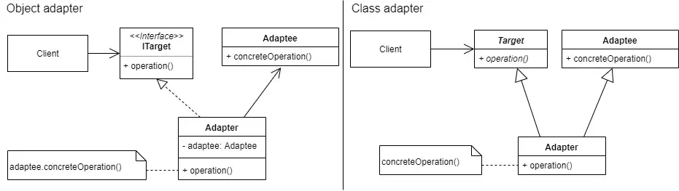

Object adapter relies on object composition to implement a Target interface in terms of (by delegating to) an Adaptee object. That is, the adapter implements the Target operation by calling a concrete operation on the property or instance of Adaptee class.
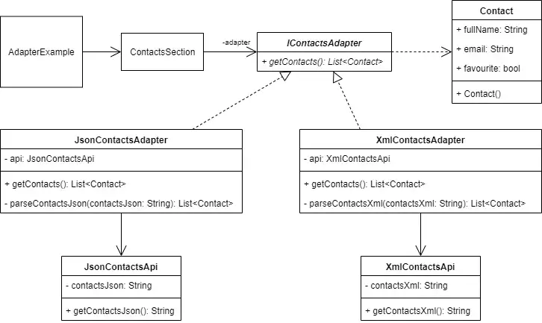
The class adapter uses inheritance to implement a Target interface in terms of (by inheriting from) an Adaptee class. This way, the concrete operation from the Adaptee class could be called directly from the implementation of Target operation. The question is, which one to use?

Implementation of object adapter
